34CS-WD- ST-2138-10 Catena Model
Draft SMPTE Standard
Warning
This document is an unpublished, confidential work under development and shall not be referred to as a SMPTE Standard, Recommended Practice, or Engineering Guideline. It is distributed for review and comment; distribution does not constitute publication. Recipients of this document are strongly encouraged to submit, with their comments, notification of any relevant patent rights of which they are aware and to provide supporting documentation.
Project Group: TC34CS Media Microservices DG
Project Technology Committee: TC34CS – Media Systems, Control and Services
Document type: ST
Document state: WD
Project chair(s): Chris Lennon
Document editor(s): Chris Lennon, John Naylor
Document number: 2138-10
Document title: Catena Interface
Title Page
This page will be provided by SMPTE HQ Staff.
See AG-16 clause 3.1 (Title Page), and ISO Directive Part 2 clause 11 (Title).
Proposed SMPTE Standard
This document is subject to change.
Copyright © 2019 SMPTE
All rights reserved.

Table of Contents Page
Foreword 4
Introduction 4
1 Scope 5
2 Normative References 5
3 Terms and Definitions 5
3.1. device 5
3.2. client 6
3.3. OID 6
3.4. FQOID 6
3.5. RPC 6
3.6. LMT 6
3.7. BLOB 6
4 The Catena Model 7
5 Registration & Discovery (Informative) 8
6 Device Data Model Notes (Informative) 8
7 Device Data Model 8
7.1. Device Model 9
7.2. DetailLevel ObjectEnum 10
7.3. MenuGroups Object 11
7.4. Params Object 12
7.5. Param Object 15
7.5.1. ParamType Object 16
7.6. Value Object 18
7.6.1. Undefined Value 18
7.6.2. Struct Value 18
7.6.3. Data Payload 18
7.7. Constraint Map 19
7.7.1. Range Constraints 20
7.7.2. Choice constraints 21
7.7.3. Alarm Table Constraint 22
7.8. Commands Map 22
7.9. LanguagePacks Map 22
7.9.1. PolyglotText Map 23
7.10. Access Scopes and Default Scope 24
8 Mandatory Params 25
9 Reserved OIDs 25
Bibliography (Informative) 25
Annex A Reserved Widget Identifiers 26

Foreword
See AG-16 3.2 (Foreword), and ISO Directive Part 2 clause 12 (Foreword).
SMPTE (the Society of Motion Picture and Television Engineers) is an internationally-recognized standards developing organization. Headquartered and incorporated in the United States of America, SMPTE has members in over 80 countries on six continents. SMPTE"s Engineering Documents, including Standards, Recommended Practices, and Engineering Guidelines, are prepared by SMPTE"s Technology Committees. Participation in these Committees is open to all with a bona fide interest in their work. SMPTE cooperates closely with other standards-developing organizations, including ISO, IEC and ITU.
SMPTE Engineering Documents are drafted in accordance with the rules given in its Standards Operations Manual. This SMPTE Engineering Document was prepared by Technology Committee TC34CS – Media Systems, Control and Services.
Normative text is text that describes elements of the design that are indispensable or contains the conformance language keywords: "shall", "should", or "may". Informative text is text that is potentially helpful to the user, but not indispensable, and can be removed, changed, or added editorially without affecting interoperability. Informative text does not contain any conformance keywords.
All text in this document is, by default, normative, except: the Introduction, any section explicitly labeled as "Informative" or individual paragraphs that start with "Note:"
The keywords "shall" and "shall not" indicate requirements strictly to be followed in order to conform to the document and from which no deviation is permitted.
The keywords "should" and "should not" indicate that, among several possibilities, one is recommended as particularly suitable, without mentioning or excluding others; or that a certain course of action is preferred but not necessarily required; or that (in the negative form) a certain possibility or course of action is deprecated but not prohibited.
The keywords "may" and "need not" indicate courses of action permissible within the limits of the document.
The keyword "reserved" indicates a provision that is not defined at this time, shall not be used, and may be defined in the future. The keyword "forbidden" indicates "reserved" and in addition indicates that the provision will never be defined in the future.
A conformant implementation according to this document is one that includes all mandatory provisions ("shall") and, if implemented, all recommended provisions ("should") as described. A conformant implementation need not implement optional provisions ("may") and need not implement them as described.
Unless otherwise specified, the order of precedence of the types of normative information in this document shall be as follows: Normative prose shall be the authoritative definition; Tables shall be next; then formal languages; then figures; and then any other language forms.

Introduction
This section is entirely informative and does not form an integral part of this Engineering Document.
This document specifies a standardization of communication methods between (micro)services and full products – designed for hybrid cloud and on-premises solutions with the goal of making it easy to secure, connect and control a multi-vendor ecosystem of media processing services and microservices no matter where they are in a true plug-and-play model.
The Hybrid Environment Reality
Today’s environments typically encompass a combination of on-premises and cloud environments. Solutions span a variety of platforms, and must interoperate, regardless of where they are hosted.

Need for More Seamless Multi-Vendor Integration
The number of devices, products and services from a wide array of vendors can be daunting, particularly with the move to microservices. Media companies need technologies to simply work together.

Security Emerging as a Priority
The need to secure environments and the connections between products and services in a standardized way is a must.

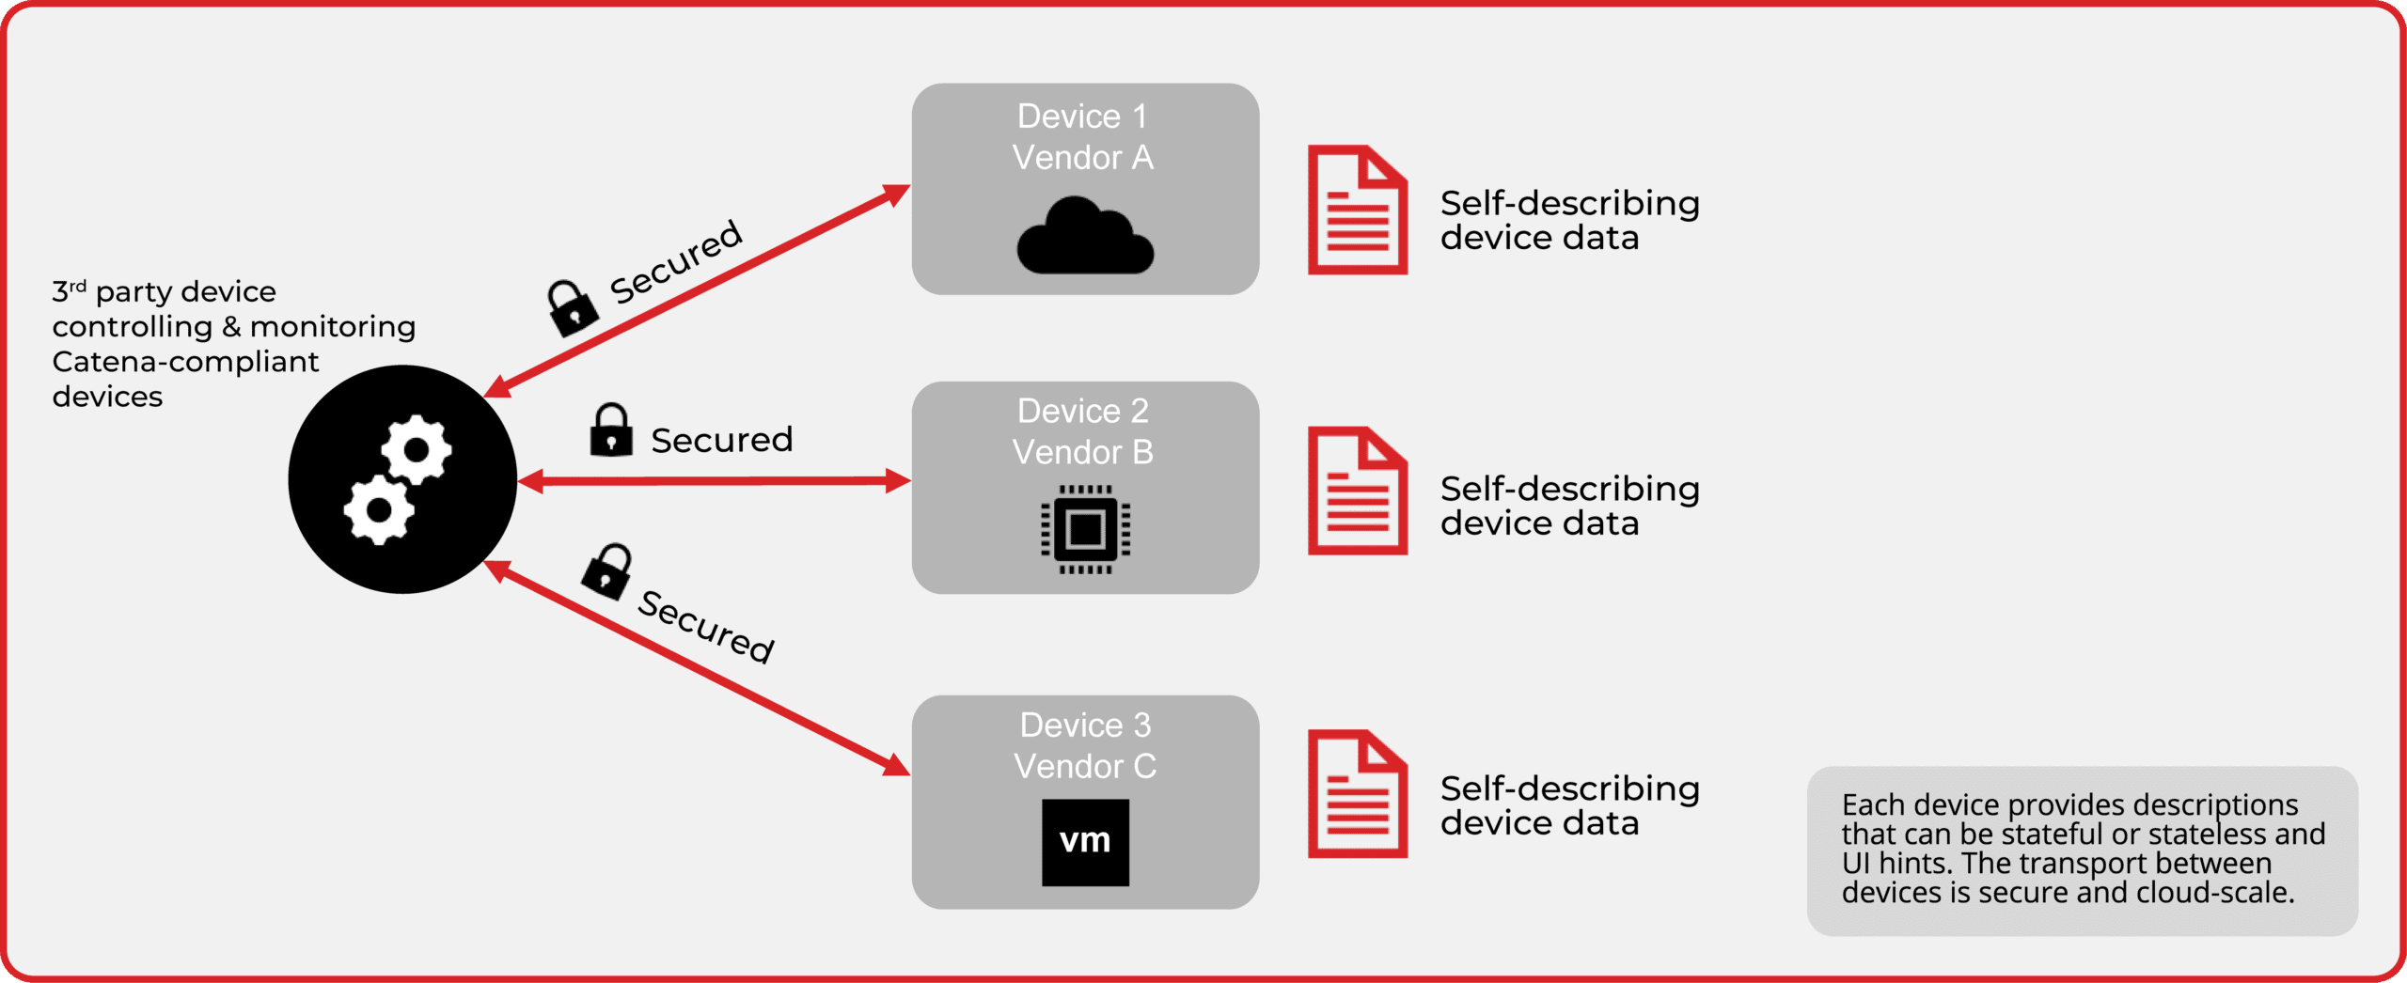

At the time of publication, no notice had been received by SMPTE claiming patent rights essential to the implementation of this Engineering Document. However, attention is drawn to the possibility that some of the elements of this document may be the subject of patent rights.
SMPTE shall not be held responsible for identifying any or all such patent rights.
Unless otherwise specified the order of precedence of the types of normative information in this document shall be as follows. Normative prose shall be the authoritative definition. Tables shall be next, followed by formal languages, then figures, and then any other language forms. In the event of a conflict between the schema and other information in this document, the schema is authoritative.

Scope
Catena is a layered protocol for control of media devices and services across platforms (cloud, on-prem, hybrid), summarized in Figure 1.
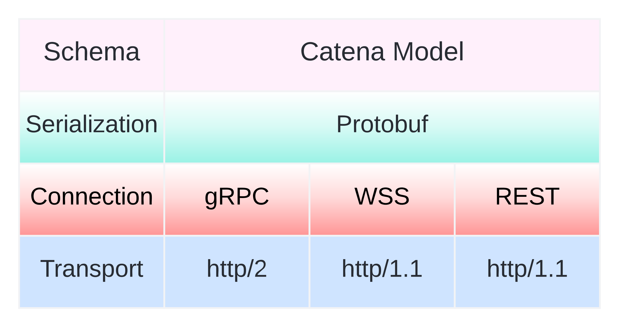
Figure 1 - Catena Architecture
The scope of this document is to define the Catena Model at the Schema layer of the architecture shown above.

Normative References
IETF RFC3066 - Tags for the Identification of Languages, H. Alvestrand, The Internet Society, 2001. http://www.ietf.org/rfc/rfc3066.txt

Terms and Definitions
For the purposes of this document, the following terms and definitions apply:

device
entity that supports the Catena Service. It may be a physical device, a microservice, or a fully featured monolithic service

client
entity that accesses resources served by Devices using the Catena Service. A Device can act in the capacity of a Client with respect to another Device

OID
object identifier, unique key of type string within a map

FQOID
fully qualified OID, a JSON pointer that uniquely identifies an object within a Device object

RPC
Remote Procedure Call

LMT
Language Metadata Table, used as a source of language codes

BLOB
Binary Large Object

Registration & Discovery (Informative)

Cloud Scale (?)
We want something that'll operate at cloud scale, though it's worth asking "Do we really?". The reason being that "cloud scale" is not a precisely defined term. It's been argued that media production operations are not cloud scale if we limit ourselves to a (generous) 10,000 collaborating services. At this scale solutions like IS-04 look promising despite being a point service.

Fast and Dynamic
We envisage using ephemeral services which spin up, get used, spin down. A discovery service needs to be able to keep up with services popping in and out of existence. Traditional DNS updates can take large fractions of an hour to propagate. Dynamic approaches such as Kubernetes DNS (and Consul, and Istio, and cloud provider service directories ...) address this need, but they're not standards.

Small and Simple
Users should be able to plug in their device, fire up their laptop, start up their control client and find their device's icon there. They shouldn't have to set up IS-04 servers, DHCP servers or DNS servers to achieve this. mDNS is ideal for this use case and there are mature open-source libraries to support it.
The test for this requirement is: zero extra servers or services are needed.
Note that strictly adhering to this requirement also rules out requiring an Authz server, the device would need to run with authz disabled.

Manual
As a last resort, users should be able to "discover" services and devices by entering their hostname or IP address into a registration dialog provided by whatever client they're using.

Options
 | Standards Based | Cloud Scale | Fast & Dyamic | Small & Simple | Comments
DNS-SD | Yes | No | No | No
mDNS | Yes | Especially Not | Yes | Yes
IS-04 | No | No, but possibly good enough | Unknown | No
Modern alternatives such as K8s DNS | No | Yes | Yes | No
Event driven protocols such as MQTT | Yes | Possibly, it's certainly used with cloud services today. | Possibly | No, needs a broker | MQTT isn't a discovery technology per se, it's a pub/sub technology, but discovery information could be what is pub/sub'd
NATS

The Catena Model
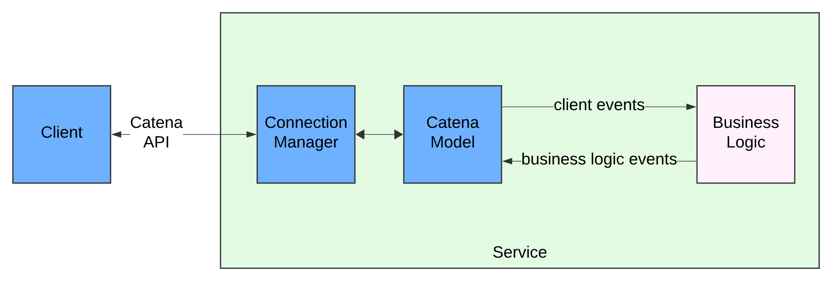
Figure 2 - Catena Device Architecture
Figure 2 provides a high-level view of a Catena compatible device’s architecture and the Catena Model’s place within it.
The objective is to isolate the model from both the device’s Business Logic, and the Connection Manager, which could be implemented using gRPC, REST, or WSS. The Catena Model defines the schemata of the objects that travel across the Connection.
A Catena Model comprises at least one, and possibly multiple Device Model objects each of which has a locally unique address called a “slot number”.
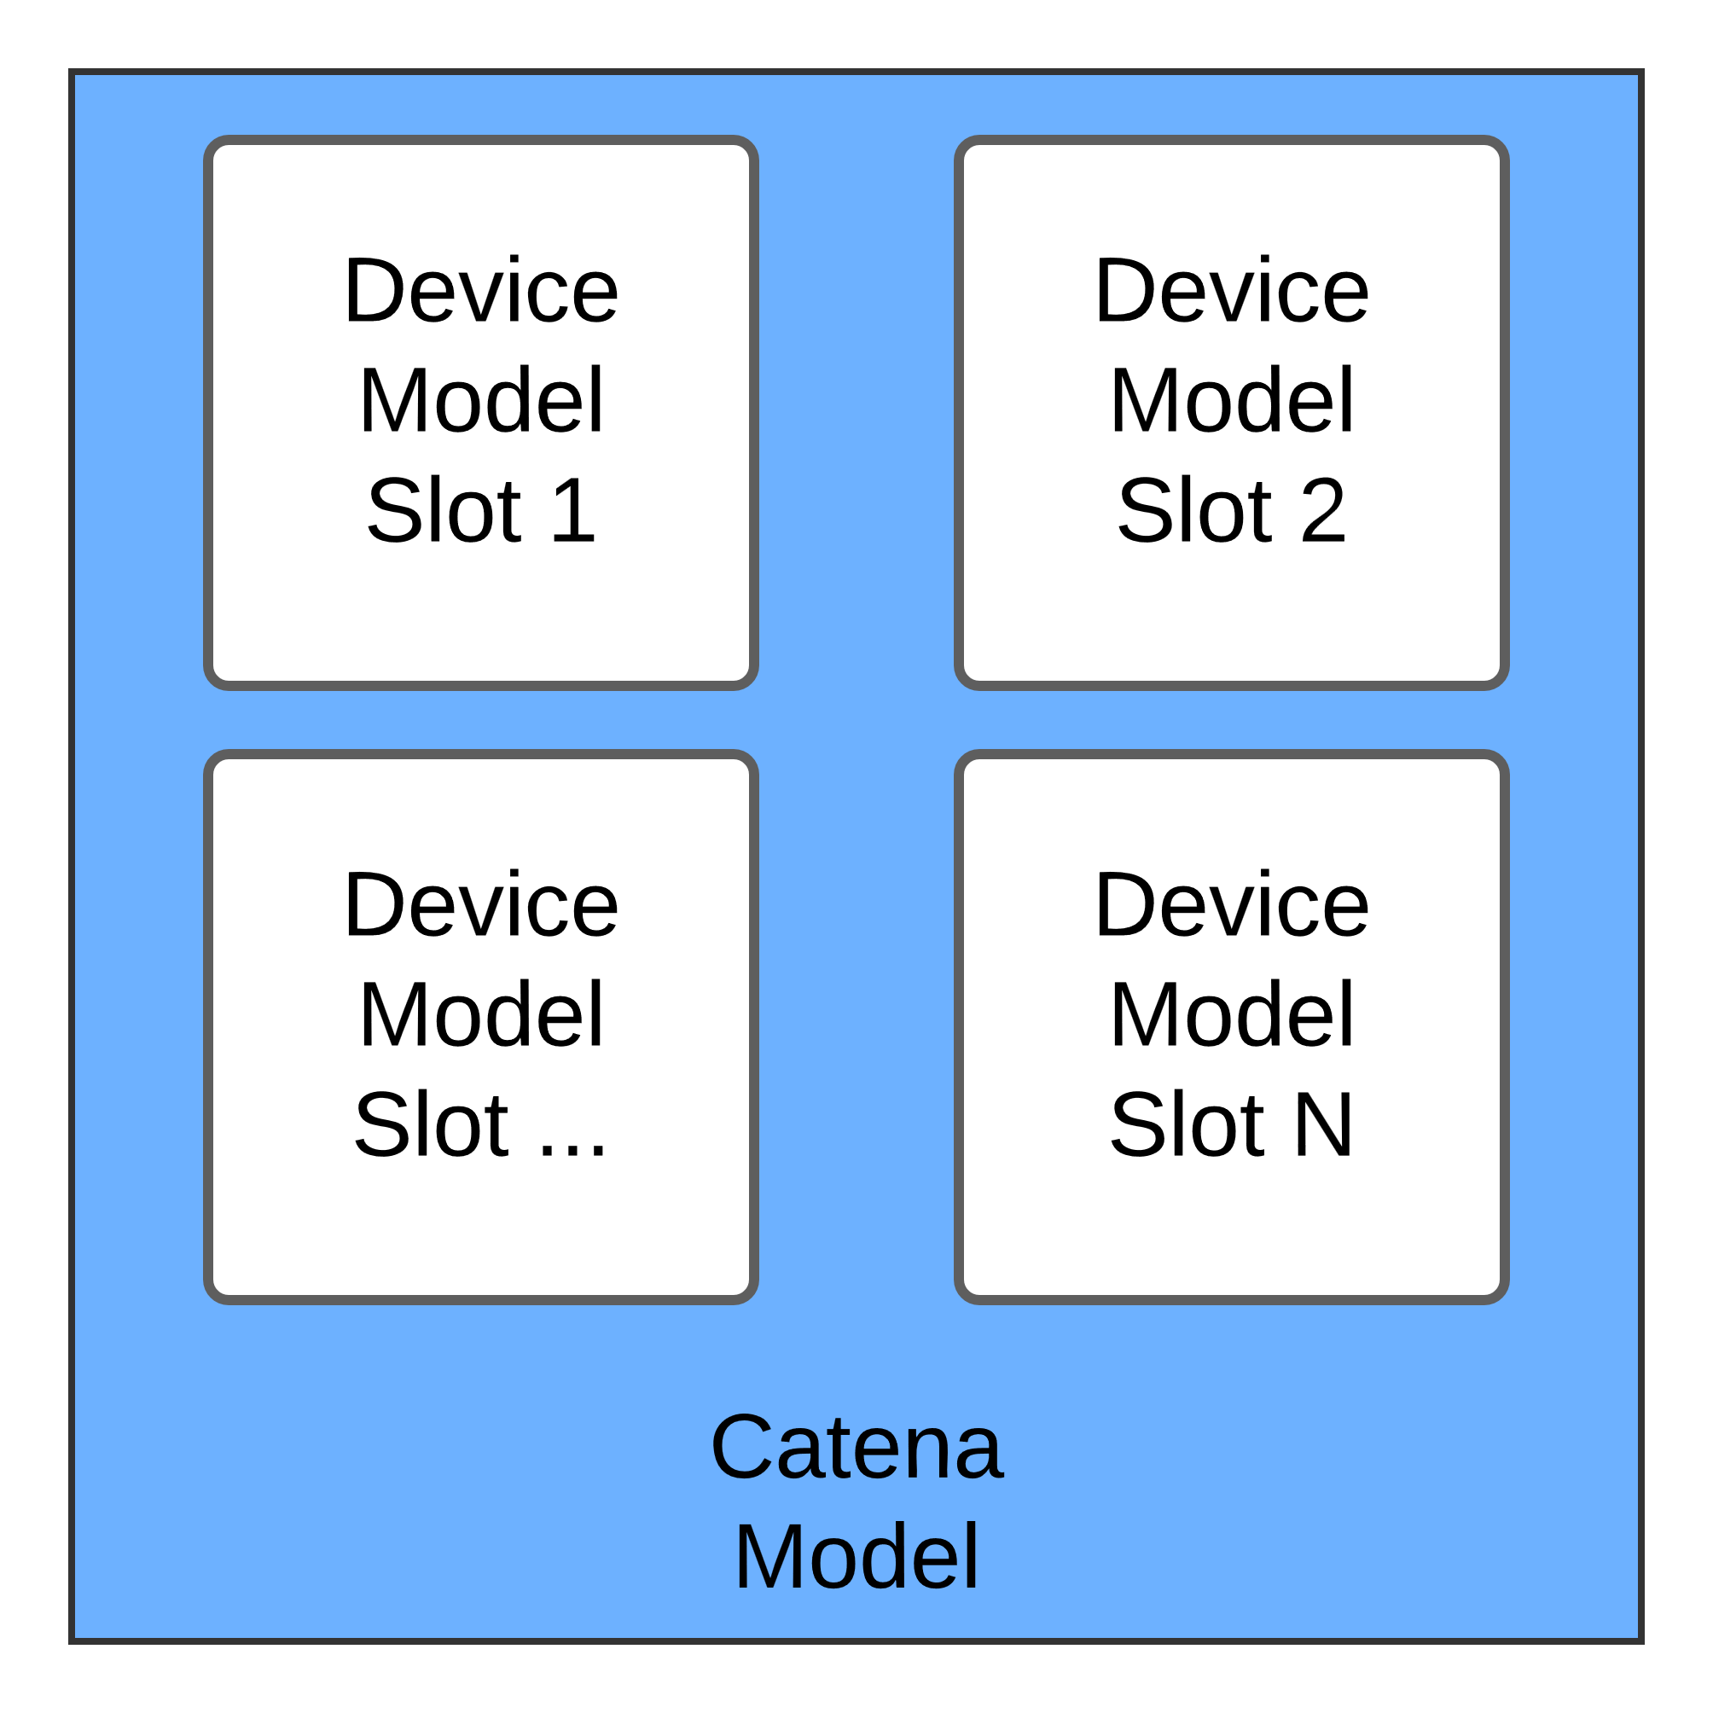
Figure 3 - Device Models

As shown in Figure 3, slot numbers do not need to be contiguous, just locally unique.
The purpose of the Catena Device Model is to describe what controls, alarms, and monitoring information a device has, and how to access them.

Device Data Model

Device Data Model Overview
The Device Data Model is highly flexible and supports:
- Scalability from small, simple devices with minimal state to large, complex devices with tens of MB of state.
- Aggregation of small, possibly industry standard, components. For example, a 4-band EQ may have a well-defined and globally agreed representation that may be imported into a larger Device that wants to include one.
- Partitioning – a Device may be split into partitions via a TBD capability included in the Device Model and Catena Service. For example, a 3 M/E switcher could be partitioned to look as though it were a 1 M/E plus a 2 M/E switcher. Another example is providing access only to a sub-matrix within a router’s full set of inputs and outputs.
- Fine-grained access control by assigning every piece of state and every command within the Device Model an appropriate Access Scope. Bearer tokens that accompany each API call will either confirm that the scope in question can be accessed or not. Note that the process and business logic of how these bearer tokens are generated is outside the scope of this standard which is limited to defining the Device policy enforcement.
- Highly scalable access control by defining a standard set of Access Scopes that all Catena Devices shall honor.

The Catena Device Data Model shall consist of a collection of objects, as defined in the subclauses below.

Device Model
Figure 4 shows a high-level view of the Catena device model.
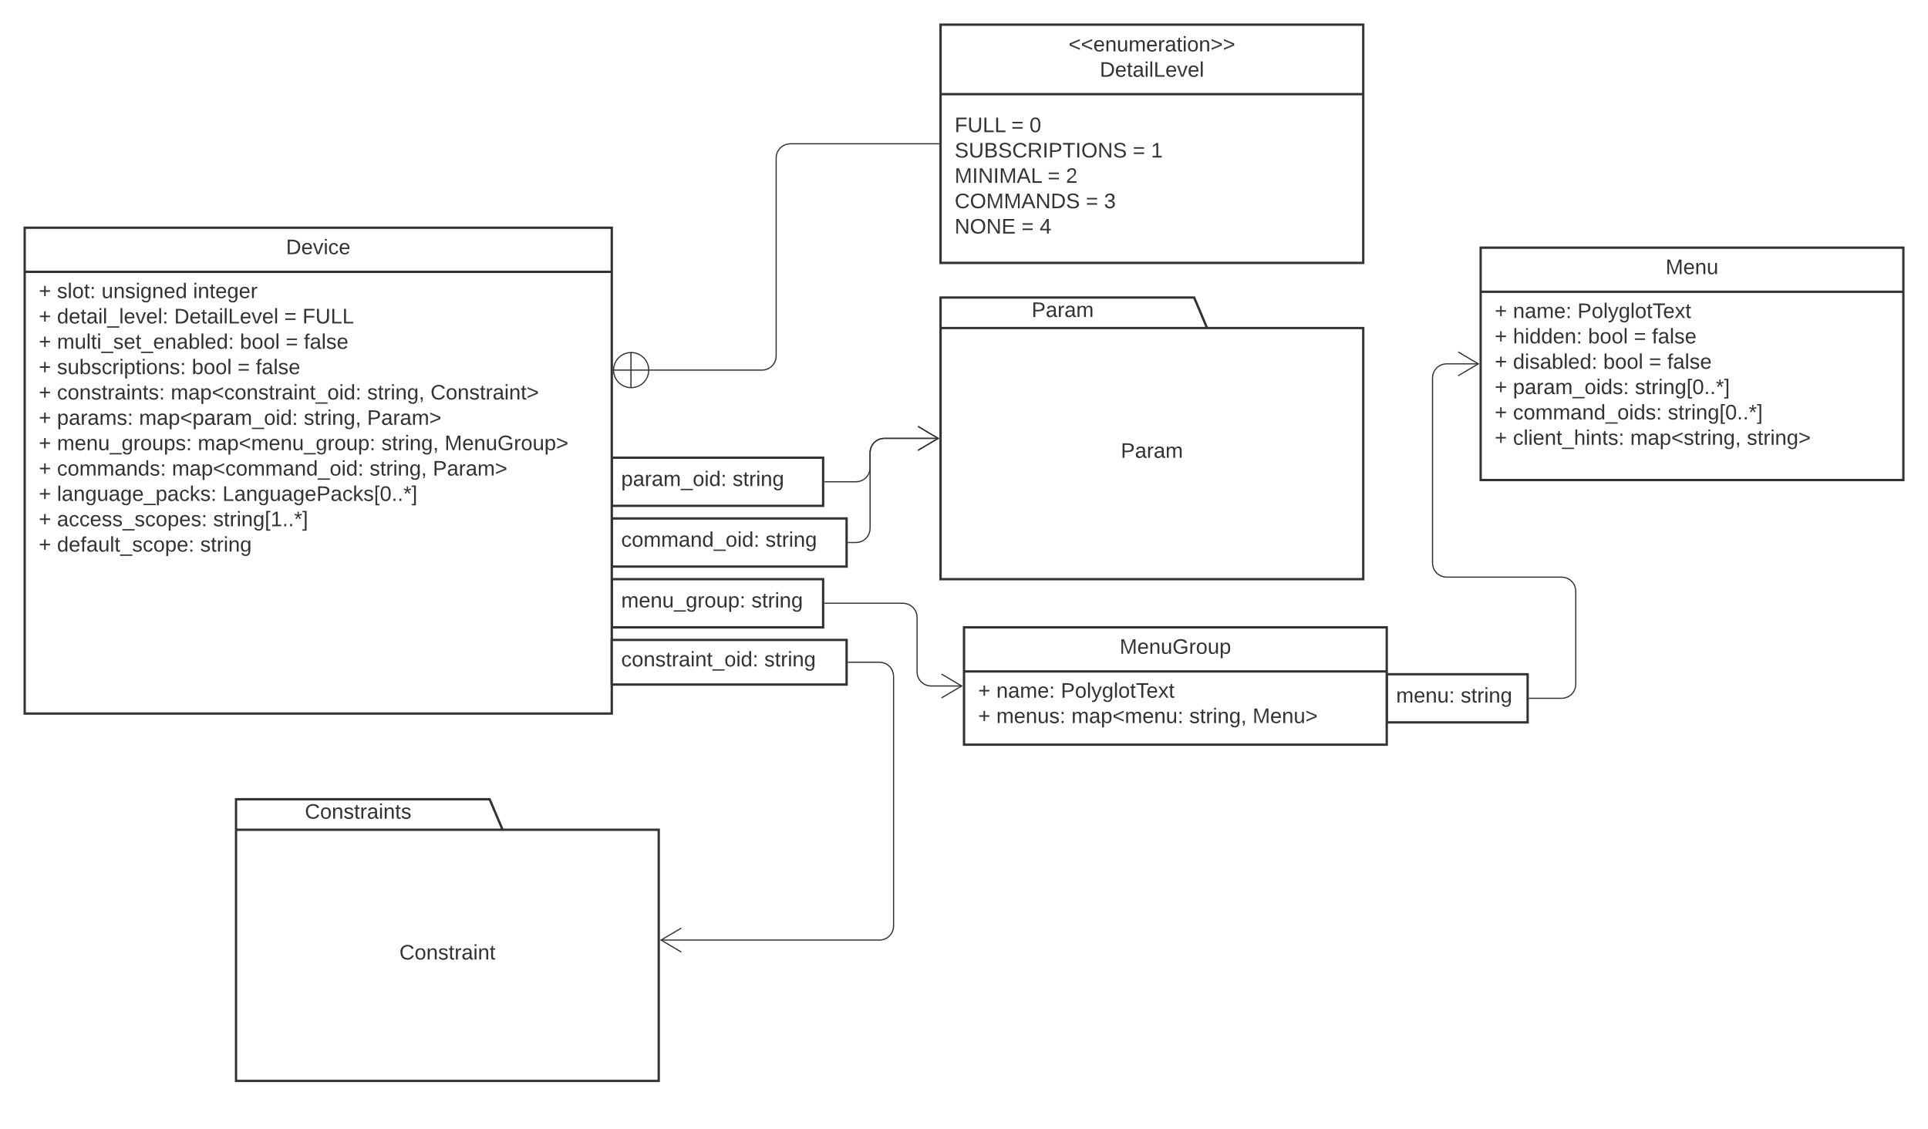
Figure 4 The Top-level Device Model, Names plus Relations with Param and Types of MembersMenuGroup

The Device Object shown in Figure 4 contains members shown in detail in Table 1 Members of the Device Object
Table 1 Members of the Device Object
Member | Default | Comments
slot | 0 | Shall be unique within the scope of the Catena Connection
detail_level | 0, i.e. Full | See 7.2.1 DetailLevel Object
multi_set_enabled | false | When true, indicates that the Device supports the MultiSetValue Request
subscriptions | false | When true, indicates that the Device supports subscriptions
timeout | 0, i.e. no timeout | Device timeout in ms if non-zero
menu_groups | Empty map | See 7.3 MenuGroups Object
params | Empty Map | See 7.4 Param Object  Params Object
commands | Empty Map | See 7.5 Value Object  Commands
language_packs | Empty Map | See 7.6 LanguagePacks
access_scopes | Empty Array | See 7.7 Access Scopes and Default Scope
default_scope | 0 | Devices shall constrain the value of this member to the interval [0, number of access scopes)

DetailLevel ObjectEnum
Table 2 provides all of the possible values and semantics for the Detail Level ObjectEnum.
Table 2 - Detail Level Enumeration
Label | Value | Meaning
FULL | 0 | The Device shall provide the whole model when it responds to the DeviceRequest message and provide every change in state to connected and authorized Clients
SUBSCRIPTIONS | 1 | The Device shall only provide its Minimal plus Subscribed state when it responds to the DeviceRequest message and only provide PushUpdates to connected Clients that are in either the Minimal or the Subscribed sets of state.
MINIMAL | 2 | The Device shall only provide its Minimal state when it responds to the DeviceRequest message and only provide PushUpdates to connected Clients that are defined to be within the Minimal set.
COMMANDS | 3 | The Device shall only provide its Commands when it responds to the DeviceRequest message.
NONE | 4 | The Device shall not provide any state in response to the DeviceRequest message.

MenuGroups Object
As illustrated in Figure 4, the MenuGroups object is a map of strings to MenuGroup objects, as shown in Table 3 and Table 4.
Table 3 - MenuGroup Object
Member | Default | Comments
name | Empty object | A PolyglotText object. The design intent for attached clients to use this information to give the menu group a name visible to the user. See PolyglotText Map.
menus | Empty list | A list of Menu Objects

Table 4 - Menu Object
Member | Default | Comments
name | Empty object | A PolyglotText object. The design intent for attached clients to use this information to give the menu a name visible to the user. See PolyglotText Map.
hidden | false | Indicates that attached clients should not display this menu.
disabled | false | Indicates that attached clients should display this menu in a read-only state.
param_oids | Empty list | A list of parameter object ids – the parameters to which this menu provides access.
command_oids | Empty list | A list of command object ids – the commands to which this menu provides access.
client_hints | Empty map | A map of strings to strings. The design intent is to provide a way for services to provide custom information to attached clients. Clients are not obliged to parse or honor client hints.

Params Object
The Params Object is a map of OIDs to Param objects.
The params object is a member of the top-level Device Object. It may also appear as a child of the Param Object which means that parameters may (and should!) be organized hierarchically.
As an example, consider a parameter that represents a geographical location.
In C or C++, it could be represented thus:
struct Location {
struct Angle {
int degrees;
int minutes;
int seconds;
};
Angle latitude;
Angle longitude;
float elevation;
}

This is a nested structure to demonstrate a hierarchy of parameters.
A device model that had a Location parameter could be serialized as JSON thus:
{
…
“constraints”: {
“sexagesimal”: {
“min_value”: 0,
“max_value”: 59,
“step”: 1
}
},
“params”: {
“angle”: {
“type”: “STRUCT”,
“params”: {
“degrees”: {
“type”: “INT32”
},
“minutes”: {
“type”: “INT32”,
“constraint”: {“ref_oid”: “/sexagesimal”}
},
“seconds”: {
“type”: “INT32”,
“constraint”: {“ref_oid”: “/sexagesimal”}
},
}
},
“location”: {
“params”: {
“latitude”: {
“template_oid”: “/angle”
},
“longitude”: {
“template_oid”: “/angle”
},
“elevation”: {
“type”: “FLOAT”
}
},
“value”: {
“struct_value”: {
“fields”: {
“latitude”: {
“value”: {
“struct_value”: {
“fields”: {
“degrees”: {“value”: {“int32_value”: 0}},
“minutes”: {“value”: {“int32_value”: 0}},
“seconds”: {“value”: {“int32_value”: 0}}
}
}
}
},
“longitude”: {
“value”: {
“struct_value”: {
“fields”: {
“degrees”: {“value”: {“int32_value”: 0}},
“minutes”: {“value”: {“int32_value”: 0}},
“seconds”: {“value”: {“int32_value”: 0}}
}
}
}
},
“elevation”: {“value”: {“float_value”: 0.0}}
}
}
}
}
},
…
}

Param Object

Param Object Details
The Param Object structure is illustrated in Figure 5, with the detailed members of Param listed in Table 5 Param.
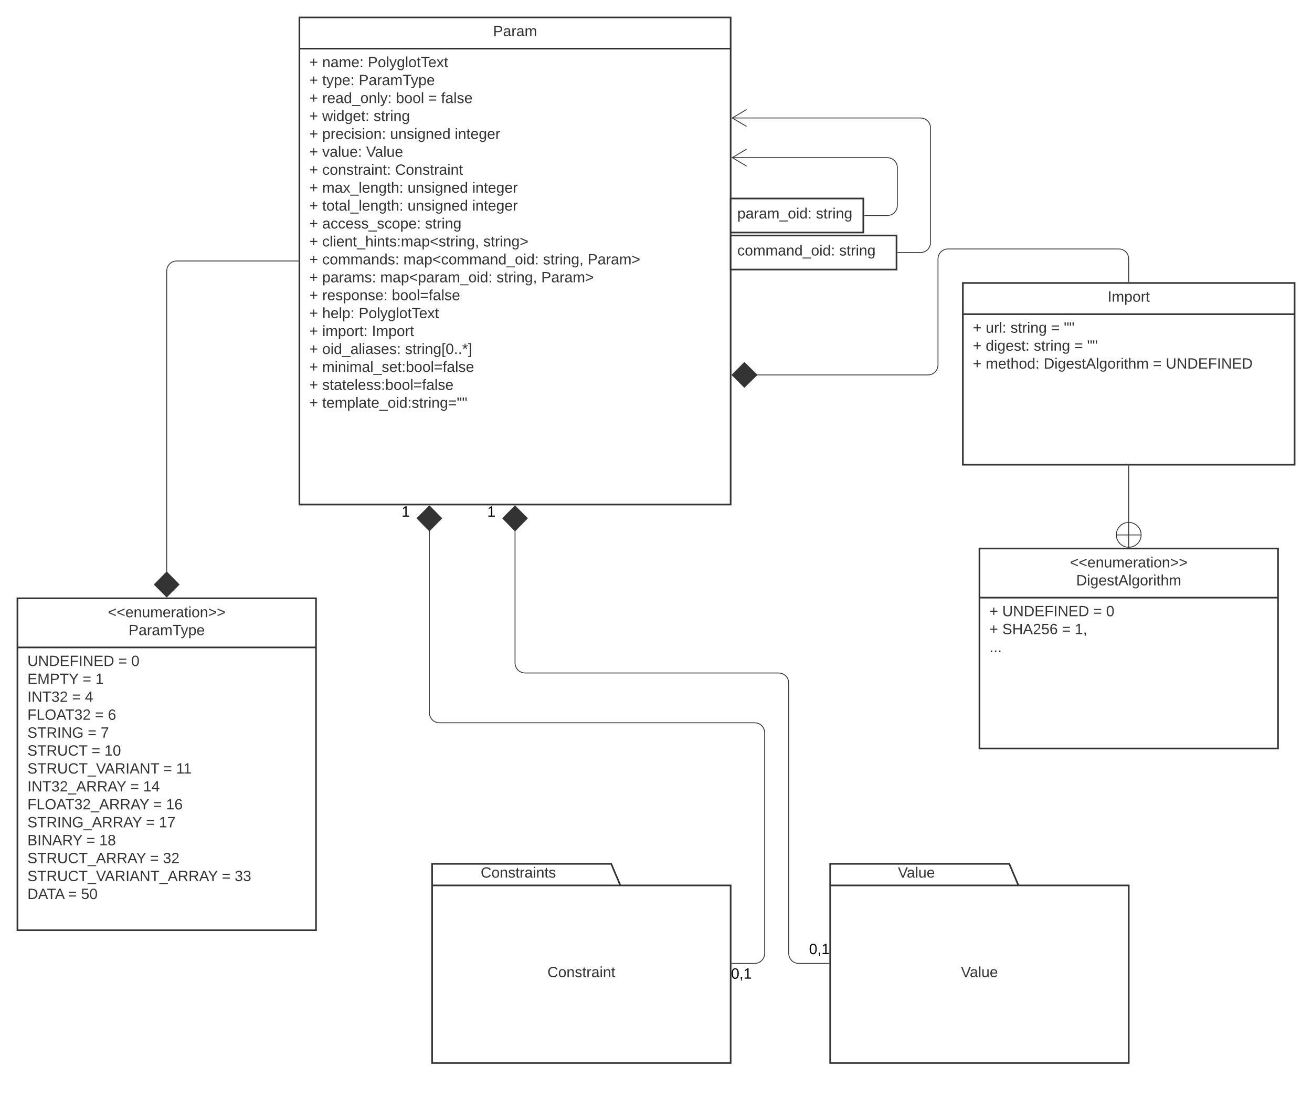
Figure 5 Param

Table 5 Param
Member | Default | Comments
name | Empty Polyglot Text Object | See 7.8.1 PolyglotText
type | UNDEFINED, 0 | See 7.6.1 ParamType Object
read_only | false | When true, indicates that the parameter is read-only
widget | Empty string | Used to provide UI hint to the Client
precision | 0 | Sets the display precision for FLOAT32 and FLOAT32_ARRAY, parameters
value | undefined_value | See 7.7 Value Object
constraint | UNDEFINED, 0 | See 7.8 Constraint Object
max_length | 0 | For STRING params, the maximum length of the string.  For ARRAY params, the maximum number of elements in the array. If zero, the size of the string or array is variable. To prevent DoS attacks, it is strongly recommended that devices set this to a non-zero value.
total_length | 0 | For STRING_ARRAY params, the total length of all strings in the array.
access_scope | Empty string | See 7.9 Access Scopes and Default Scope
client_hints | Empty map | Intent is to enable further configuration information about the widget member to be provided as a key/value map
params | Empty map | See 7.4 Params Object
commands | Empty map | See 7.9 Commands Object
response | false | True when the descriptor is a member of a commands map, and the command sends a response back to the client. Has no meaning within a params map
mimimal_set | false | True to indicate that the command or param is a member of the minimal set.
help | Empty PolyglotText object | See 7.8.1 PolyglotText Object
import | Default Import Object | See Import Object
oid_aliases | Empty array | Additional identifiers for this parameter – used to allow a client to locate a parameter that may have been moved or renamed
stateless | false | Indicates that the parameter value is only useful in the instant. Examples are: time of day, audio level. The intent of this flag is to enable clients to avoid putting the values into persistent storage.
template_oid | Empty string | A json-pointer to a parameter that is used as template. Note that scalar templates can be used for array parameters.

ParamType Object
Table 6 provides an enumeration for the ParamType Object with the following possible values and semantics:
Table 6 ParamType Enumeration
Label | Value | Meaning
UNDEFINED | 0 | Parameter type is undefined
EMPTY | 1 | Parameter type is empty /Users/jnaylor/Projects/Catena/interface/service.proto
INT32 | 4 | Parameter has 32-bit integer value, its constraint, if present is an integer constraint
FLOAT32 | 6 | Parameter has a 32-bit float value, its constraint, if present will be a float constraint
STRING | 7 | Parameter has a string value, its constraint, if present, will be a string constraint
STRUCT | 10 | Parameter is a structure with members defined by the parameter’s params member and values of type struct_value. Structure members need not all be present in the value instances. Its constraint, if present, will be a struct constraint
STRUCT_VARIANT | 11 | Parameter is a discriminated union with the options for its value defined by the parameter’s params member, and values of type struct_variant_value.
INT32_ARRAY | 14 | Parameter has value that is an array of 32-bit integers, its constraint, if present is an integer constraint
FLOAT32_ARRAY | 16 | Parameter has value that is an array of 32-bit floats,  its constraint, if present is a float constraint
STRING_ARRAY | 17 | Parameter has value that is an array of strings, its constraint, if present, will be a string constraint
BINARY | 18 | ///*** need help with this one
STRUCT_ARRAY | 32 | As for STRUCT except that the parameter has an array of instances of the struct_value. Its constraint, if present, will be a struct constraint
STRUCT_VARIANT_ARRAY | 33 | As for STRUCT_VARIANT except tha thte parameter has an array oif instances of struct_variant_value.
DATA | 50 | Parameter has a value that is a DataPayload object

Value Object

Value Object Details

The Value object is polymorphic. It may take one of many different types as illustrated in Figure 6. Only the more exotic types are documented here.
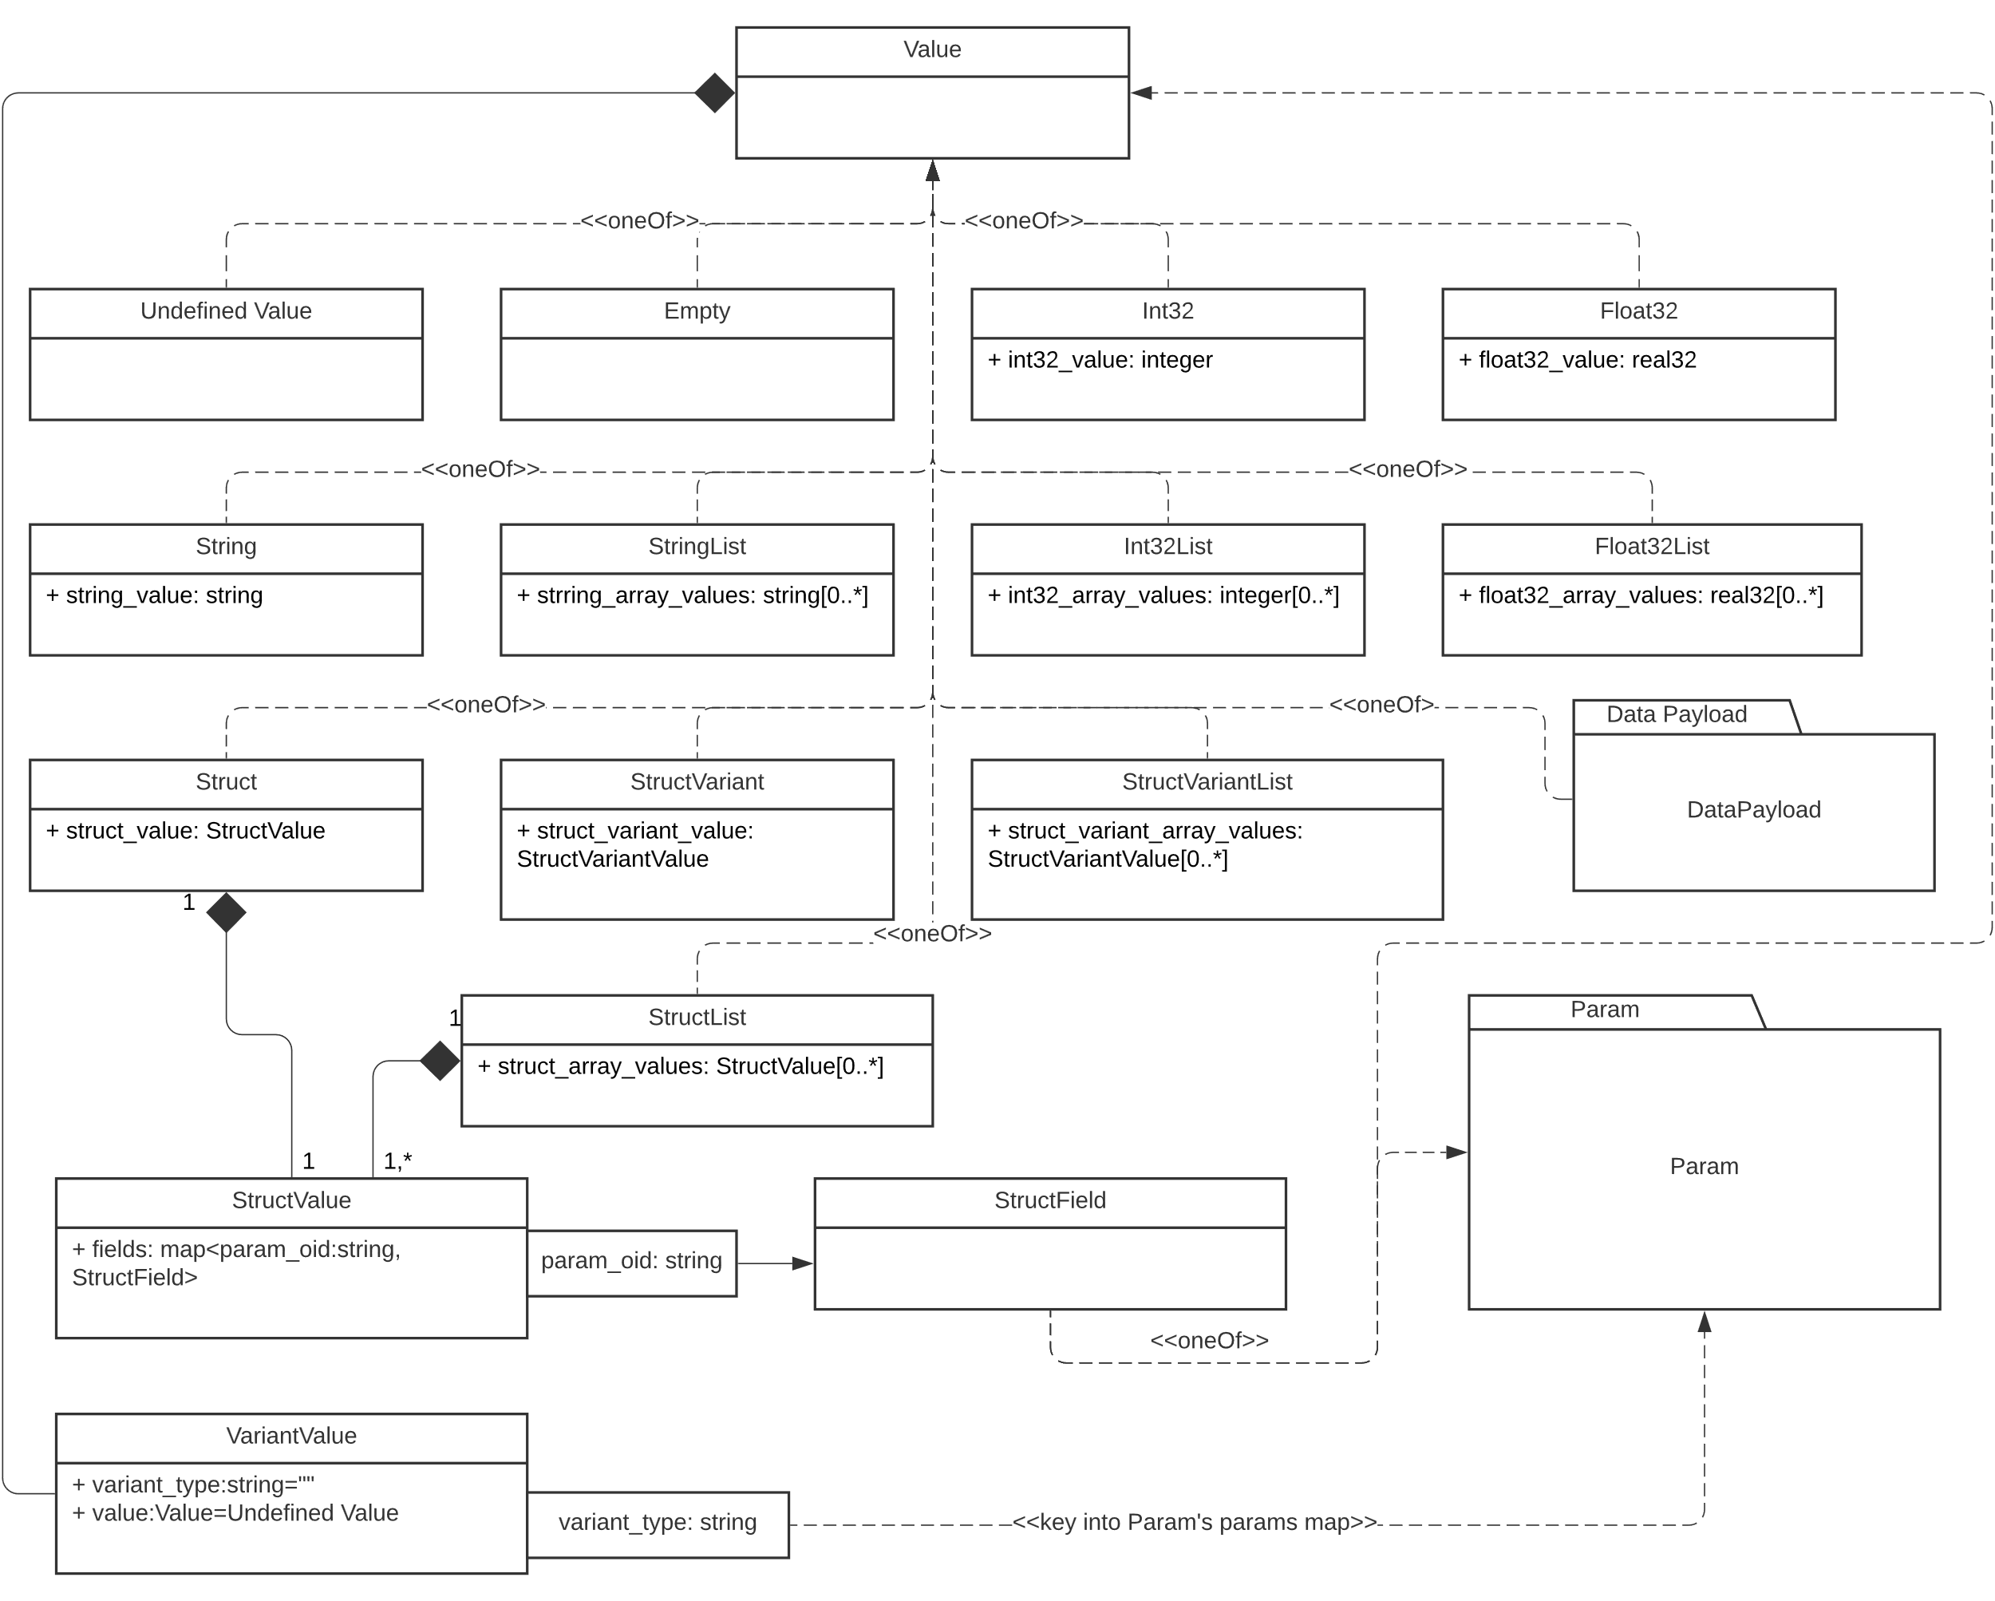
Figure 6 Value Object Polymorphism

Undefined Value
This is implemented as an enum with a single default choice labeled UNDEFINED_VALUE with value 0. It’s useful to signal when a parameter’s value has not been defined, but may become so in the future.

Struct Value
This is best explained by the example shown in 7.4.

Data Payload
The purpose of the Data Payload object is to allow a Device to send BLOBs of opaque data to a client. Both direct and by-reference methods are supported, as shown in Table 7, Table 8 and Figure 7.
Table 7 Data Payload Enumeration

Member | Default | Comments
metadata | Empty map | Information about the payload to be interpreted by the client, e.g. MIME type, filename etc
digest | Empty array | Optional SHA-256 digest of the payload. Design motivation – allow receivers to save bandwidth and time by blocking reception of assets they already have.
payload_encoding | 0, UNCOMPRESSED | See 7.9.1 PolyglotText Map

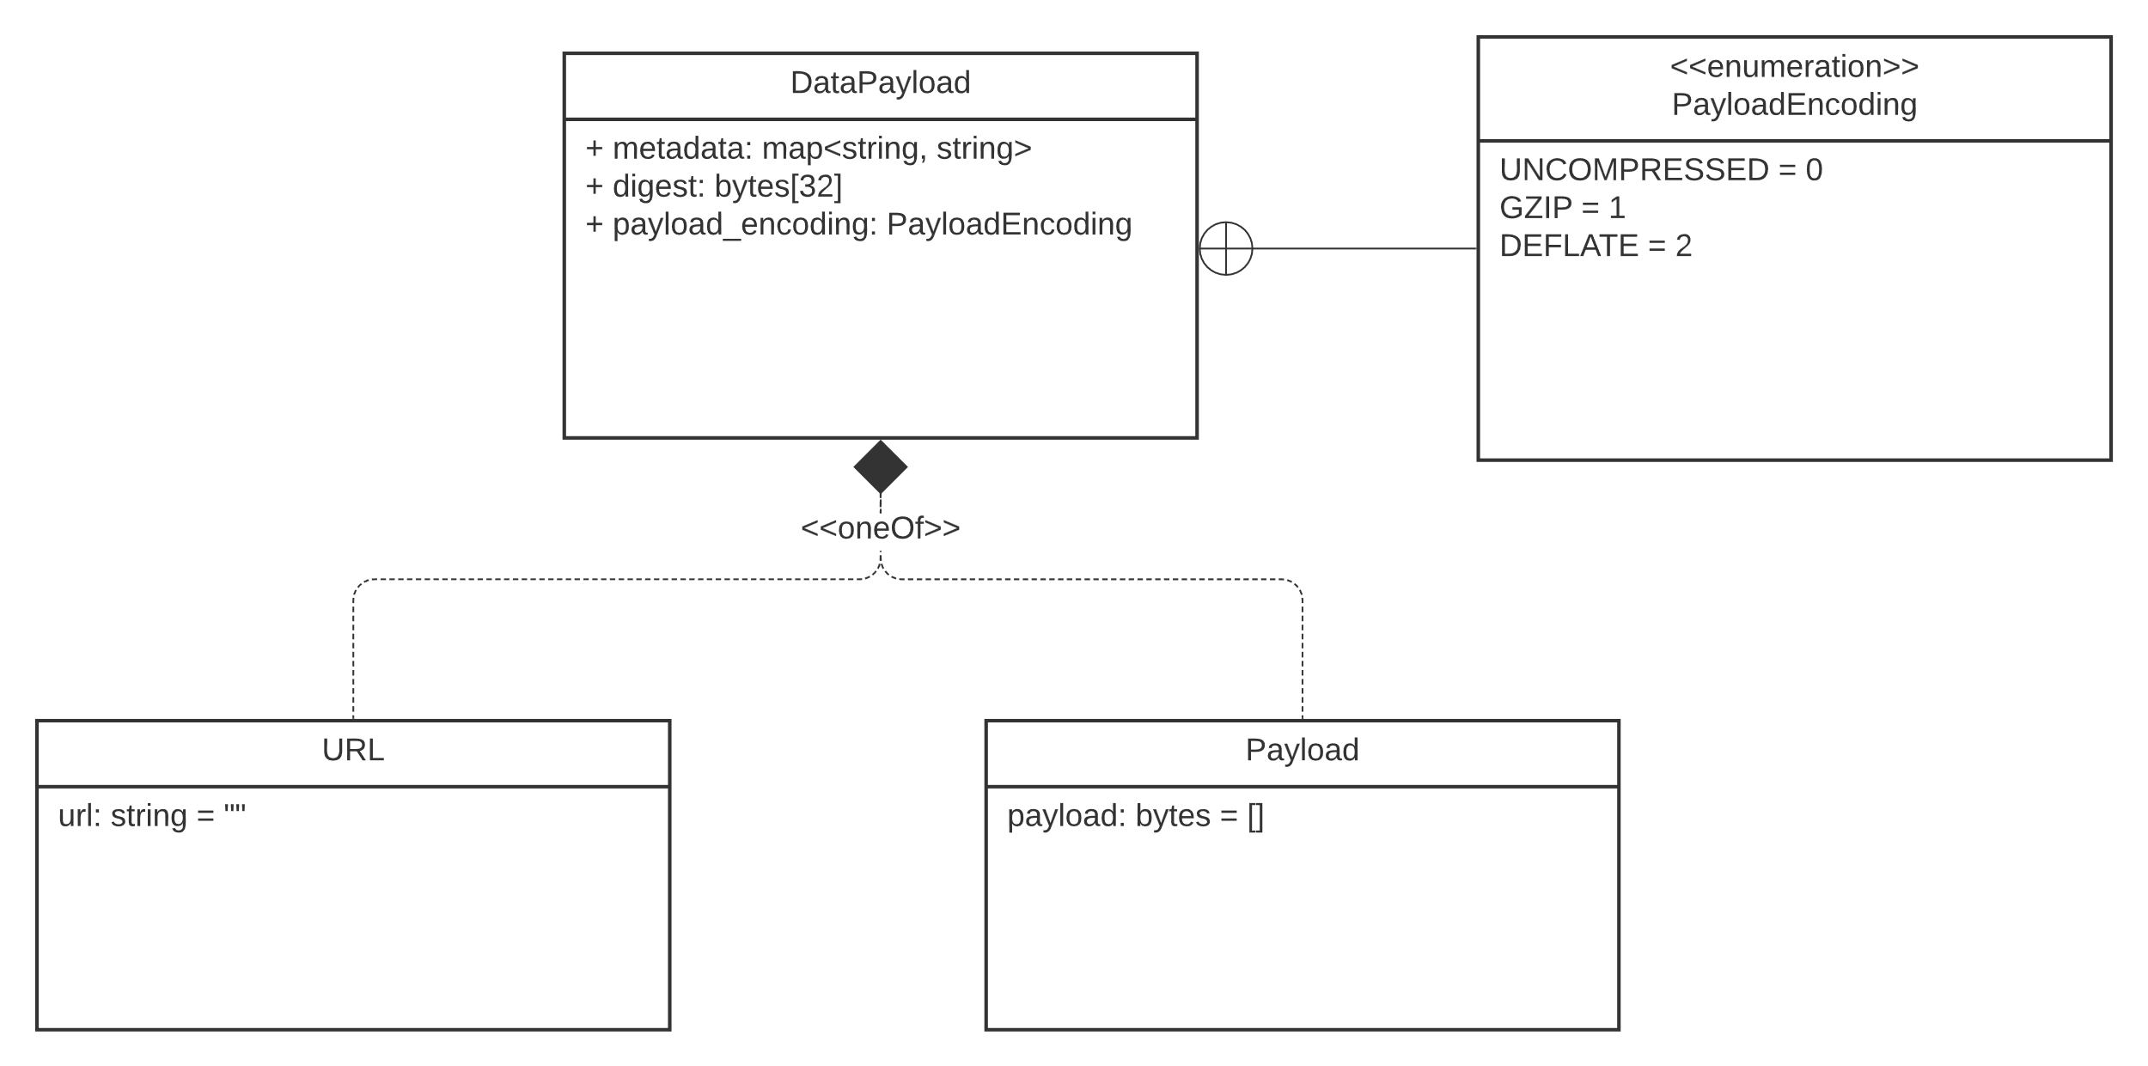
Figure 7 – DataPayload

Table 8 - DataPayload
Label | Value | Meaning
UNCOMPRESSED | 0 | The payload is not compressed
GZIP | 1 | The payload is compressed with the GZIP algorithm
DEFLATE | 2 | The payload is compressed with the Deflate algorithm

Constraint Map

Constraint Map Details
Parameter values can be constrained so that they always have legal values. There are different types of constraint according to a parameter’s type:
- Floating point and integer values can be constrained to a range
- Integers may also be constrained to enumerated values
- Integers may also be subject to an Alarm Table constraint
- Strings may be constrained to one of two types of enumerated list:
  - STRING_CHOICE, which simply lists the string choices without multi-language support
  - STRING_STRING_CHOICE which provides a key:value map to multi-language encoded strings
Constraints can be defined inside the parameter descriptor in which case they only act on that parameter’s value. Or they can be defined in the device’s constraints object and used by multiple parameters. Parameters that use a so-called “shared constraint” do so by setting the constraint objects ref_oid field to a JSON pointer relative to the device’s constraints object.
Figure 8 shows the structure of the Constraint Map.

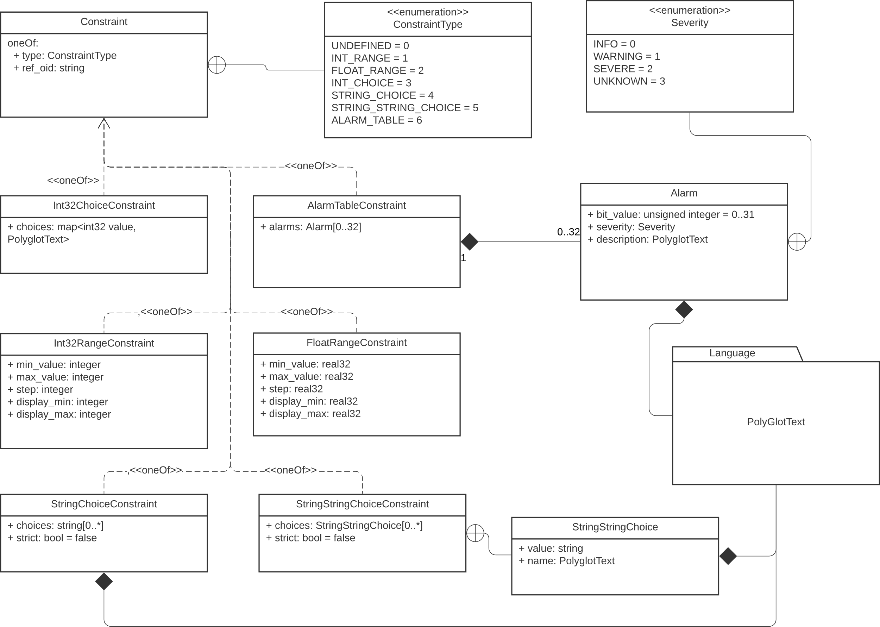
Figure 8 – Constraints

Range Constraints
Range constraints are defined by the fields shown in Table 9.
Table 9 - Range Constraints
Field | Required? | Comment
min_value | yes | The inclusive minimum parameter value
max_value | yes | The inclusive maximum parameter value
step | no | Size of increments for values within the range
display_min | no | Client hints so that the operating range of a parameter value can appear smaller or larger than its functional range which can be useful to show a parameter value in context
display_max | no

Choice constraints
Choice constraints allow for valid parameter values to be enumerated. This allows clients to provide UI elements such as drop-down menus and radio buttons for interaction. Table 10, Table 11 and Table 12 show the choice constraints for Int32, String and StringString.
Table 10 - Int32Choice Constraint
Field | Required? | Type
choices | yes | A list of value, PolyglotText objects. Each value must be a unique 32-bit integer

Table 11 - StringChoice Constraint
Field | Required? | Type
choices | yes | A list of strings that enumerate the parameter’s value
strict | no | Boolean, when true the model shall reject attempts to set the parameter value outside of the list of choices

Table 12 - StringStringChoice Constraint
Field | Required? | Type
choices | yes | A list of value : PolyglotText objects where value is of type string and must be unique within the list.
strict | no | Boolean, when true the model shall reject attempts to set the parameter value outside of the list of choices

Alarm Table Constraint
As shown in Table 13, alarm tables allow up to 32 alarms to be represented by a 32-bit integer, each bit of which is mapped to a specific alarm by the Alarm object.
Table 13 - Alarm Object
Field | Required? | Type
bit_value | yes | A number ranging from 0 to 31, inclusive. Must be unique within the containing AlarmTable
severity | yes | One of: INFO, WARNING, SEVERE, UNKNOWN
description | yes | PolyglotText object to describe the problem being alerted

Commands Map
The commands map shall be a map of string : Param object pairs. This permits a client to convey arbitrarily structured data along with a command. An example is a tape transport with a command “play” that has a value representing the play speed.
Note: Commands are stateless; the value of the play speed in our example is a separate piece of state for each invocation of the command.

LanguagePacks Map

LanguagePacks Details
LanguagePacks provide multi-language support as defined in IETF RFC 3066. Supporting clients could, for example, provide a way to switch the active language rendered on the display.
They also provide the possibility of adding language support in the field by installing additional language packs.
Each language pack shall be uniquely identified by its language code, for example:
- “es” – global Spanish
- “en” – global English
- “en-us” – US English
- “fr” – global French
The structure of a LanguagePack is shown in Figure 9
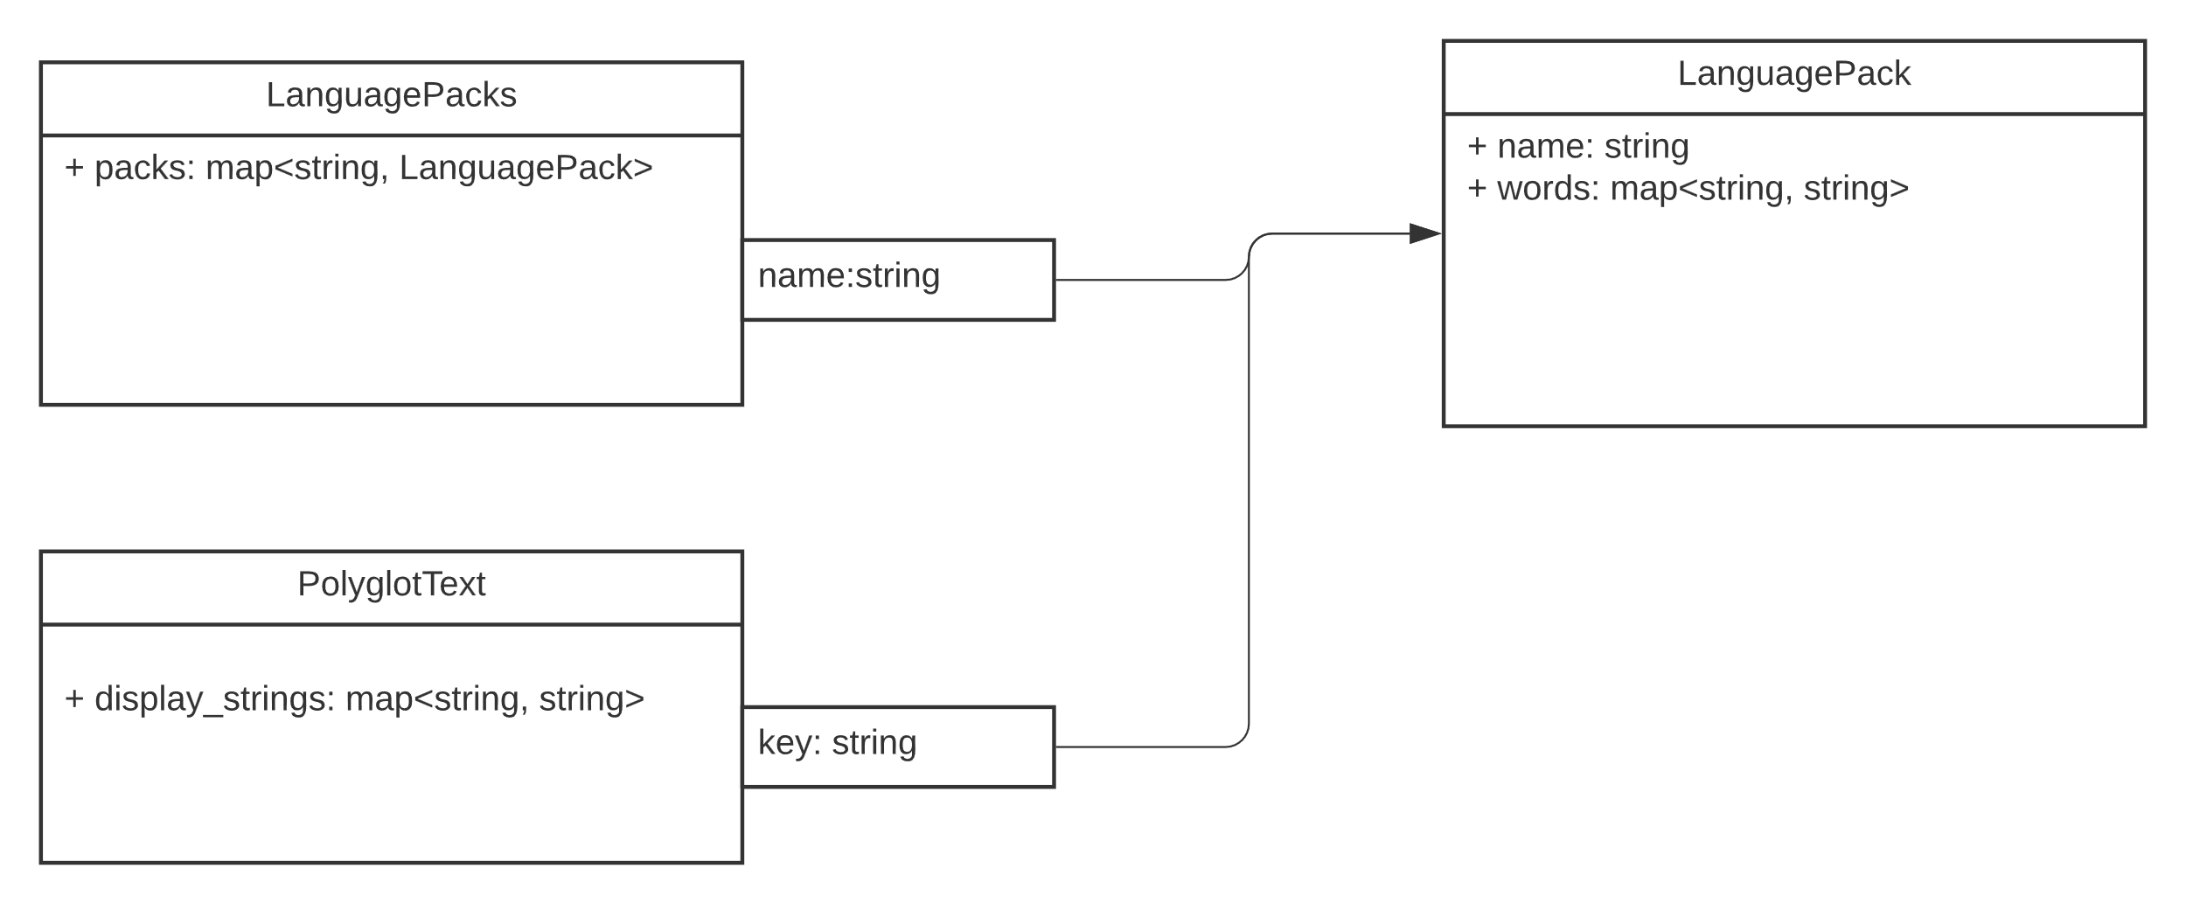
Figure 9 – Language Packs

PolyglotText Map

PolyglotText
PolyglotText is text that a client may display in one of multiple languages. The different options may either be defined in-line for each instance of this object, or they may reference a LanguagePack.
When defined in-line, the keys shall be the language codes defined by IETF RFC 3066. For example, a key with the value “$key”, which is not in IETF RFC 3066 indicates that the text to display can be accessed from a LanguagePack.

In-line PolyglotText Definition example
{
“name”: {

“en”: “Hello”,
“es”: “Hola”,
“fr”: “Bonjour”,
“en_CA”: “G’day, Eh?”
}
}

LanguagePack referencing example of PolyglotText
{
“name”: {
“$key”: “greeting”
}
}

Access Scopes and Default Scope
Access scopes enable administrators to configure fine-grained access control schemes that may be Role-based, Attribute Based, Conditional, and more. To make configurations scalable, Catena defines a small number of Access Scopes that reflect how media production equipment is used in a variety of use cases which include:
- Commissioning
- Troubleshooting
- Operating
- Auditing
- Patching & Upgrading
- Orchestrating (setting up signal flows)

The Catena Access Scopes are the following verbs:
- Monitor, e.g. Audio Level Meters, Waveform Monitors
- Operate, e.g. Audio Level Faders, Switcher Transition Faders, Router matrix buttons
- Configure, e.g. set up multicast IP addresses for input & output flows
- Administer, e.g. read logs, update firmware, reboot

Monitor is implicitly read-only. The others support read-only or read-write access being granted.
Devices shall support the Catena Access Scopes. They may augment them with extra scopes.
Every item of state (parameter) and command within the device model shall have at least one Access Scope associated with it according to these rules:

- The parameter or command shall have an explicitly defined Access Scope if its “access_scope” member is present, otherwise
- The parameter or command shall have a parent with an explicitly defined Access Scope, in which case it inherits that of the parent, otherwise
The parameter or command shall have the default access scope defined in the Device Object.

Mandatory Params
A Device shall provide all the parameters shown in Table 14.
Table 14 - Mandatory Params

Fully Qualified Object Id | Type | Scope | Information
/product/name | STRING | monitor | The name of the product
/product/vendor | STRING | monitor | The name of the product’s vendor
/product/version | STRING | monitor | The product’s software version
/product/catena_sdk | STRING | monitor | Identifier for the SDK. This could be the URL to a github repo, for example
/product/catena_sdk_version | STRING | monitor | Version number of the SDK
/product/serial_number | STRING | monitor | The product’s serial number, physical products only

Reserved OIDs
If a device uses any of these Object IDs, its use shall match the semantics noted in the Table 15.
Table 15 - Reserved OIDs
Fully Qualified Object Id | Type | Scope | Purpose
/product/options | STRING ARRAY | monitor | List of fitted options
/product/icon | STRING | monitor | Path to the product’s icon. Intended for clients to access via an External Object Request.
/openGear/<oid> | Any | Any | Backwards compatibility with openGear reserved OIDs where <oid> is substituted by the openGear reserved OID

- Reserved Widget Identifiers
Reserved Widget Identifiers are shown in Table 16.
Table 16 - Reserved Widget Identifiers
Widget Identifier | Suggested Rendering | Suggested Client Hints
default | Client decision
text-display | Read-only text view
hidden | Do not render the parameter or command
label | Parameter value formatted as a label
text | Line of text
password | Text entry that renders stars or circles in response to keystrokes
combo | Drop-down list
dot | A status LED with text | Color
html-text | Text display with HTML formatting
multiline-text | Text entry box
toggle | Toggle button | Should be accompanied by a constraint that defines option 0 = off and option 1 = on
checkbox | Checkbox
radio | Group of radio buttons | Should be accompanied by one of the Choice constraints
list | list
tree | tree
tree-popup | Pop-up tree
color-picker | Color picker
color-picker-popup | Pop-up color picker
file-picker | File system navigator and file selector
spinner | Numerical display with a pair of “nudge” buttons
slider | slider | Orientation: horizontal | vertical
wheel | Thumbwheel | Orientation: horizontal | vertical
fader | fader | Type: audio | video
date-picker | Calendar view with date picker
time-picker | Time display with ability to set time | Clock: 12 hour | 24 hour  Hours: on | off  Minutes: on | off  Seconds: on | off
eq-graph | A line graph showing gain in dB vs frequency with dots to show the center/cut frequency of the various members of the eq. | << need info from JP >>
line-graph | A line graph showing the history of a parameter value | << need info from JP >>
button | A push button
ip-v4 | 4 decimal number field data entry with validation that range is 0-255 for each field.
ip-v6 | 8 hex number field data entry with validation that range is 0-0xFFFF for each field.
progress | Progress Meter | Orientation vertical | horizontal
level-meter | Audio meter | Orientation: vertical | horizontal  Colors and Ranges: << needs work >>  Growth Direction: up | down | left | right
positioner | Movable cross hairs within a rectangle
joystick | Joystick
scroll | Scroll bar | Orientation: vertical | horizontal

Bibliography (Informative)

